- Rising price pressures mean UK households face a severe squeeze on their finances over the next couple of years. We think workers will struggle to secure stronger pay rises to mitigate the impact of the inflation shock, which will be compounded by tighter fiscal policy and higher debt servicing costs.
- We expect real household income to flatline this year, which would be the worst performance since 2022. However, we anticipate households will reduce their savings to cushion some of the blow, in a repeat of their behaviour in 2022-2023, so we still expect consumer spending to grow slowly across 2026 and 2027.
- Higher inflation will likely be concentrated in ‘essential’ categories – food, energy, petrol – that comprise much larger shares of lower-income household spending. These households also appear to be entering the latest energy shock in a more vulnerable financial position than the last one.
The consumer has been central to the UK’s sluggish growth performance in recent years. But inflationary pressures are now intensifying due to the surge in oil and gas prices since the start of the Middle East conflict, compounding the drags from tightening fiscal policy and already-elevated interest rates. As a result, we expect household finances will come under renewed strain over the next couple of years.
Households have been very cautious since the pandemic, saving an unusually high share of their income and showing muted demand for credit. We think a partial reversal of these trends will help households to mitigate some of the upcoming squeeze on spending power, but the severity of the energy shock means we still think consumer spending growth will slow to just 0.6% this year and 0.4% in 2027 (Chart 1).
Chart 1: We expect growth in consumer spending to weaken as real household incomes contract
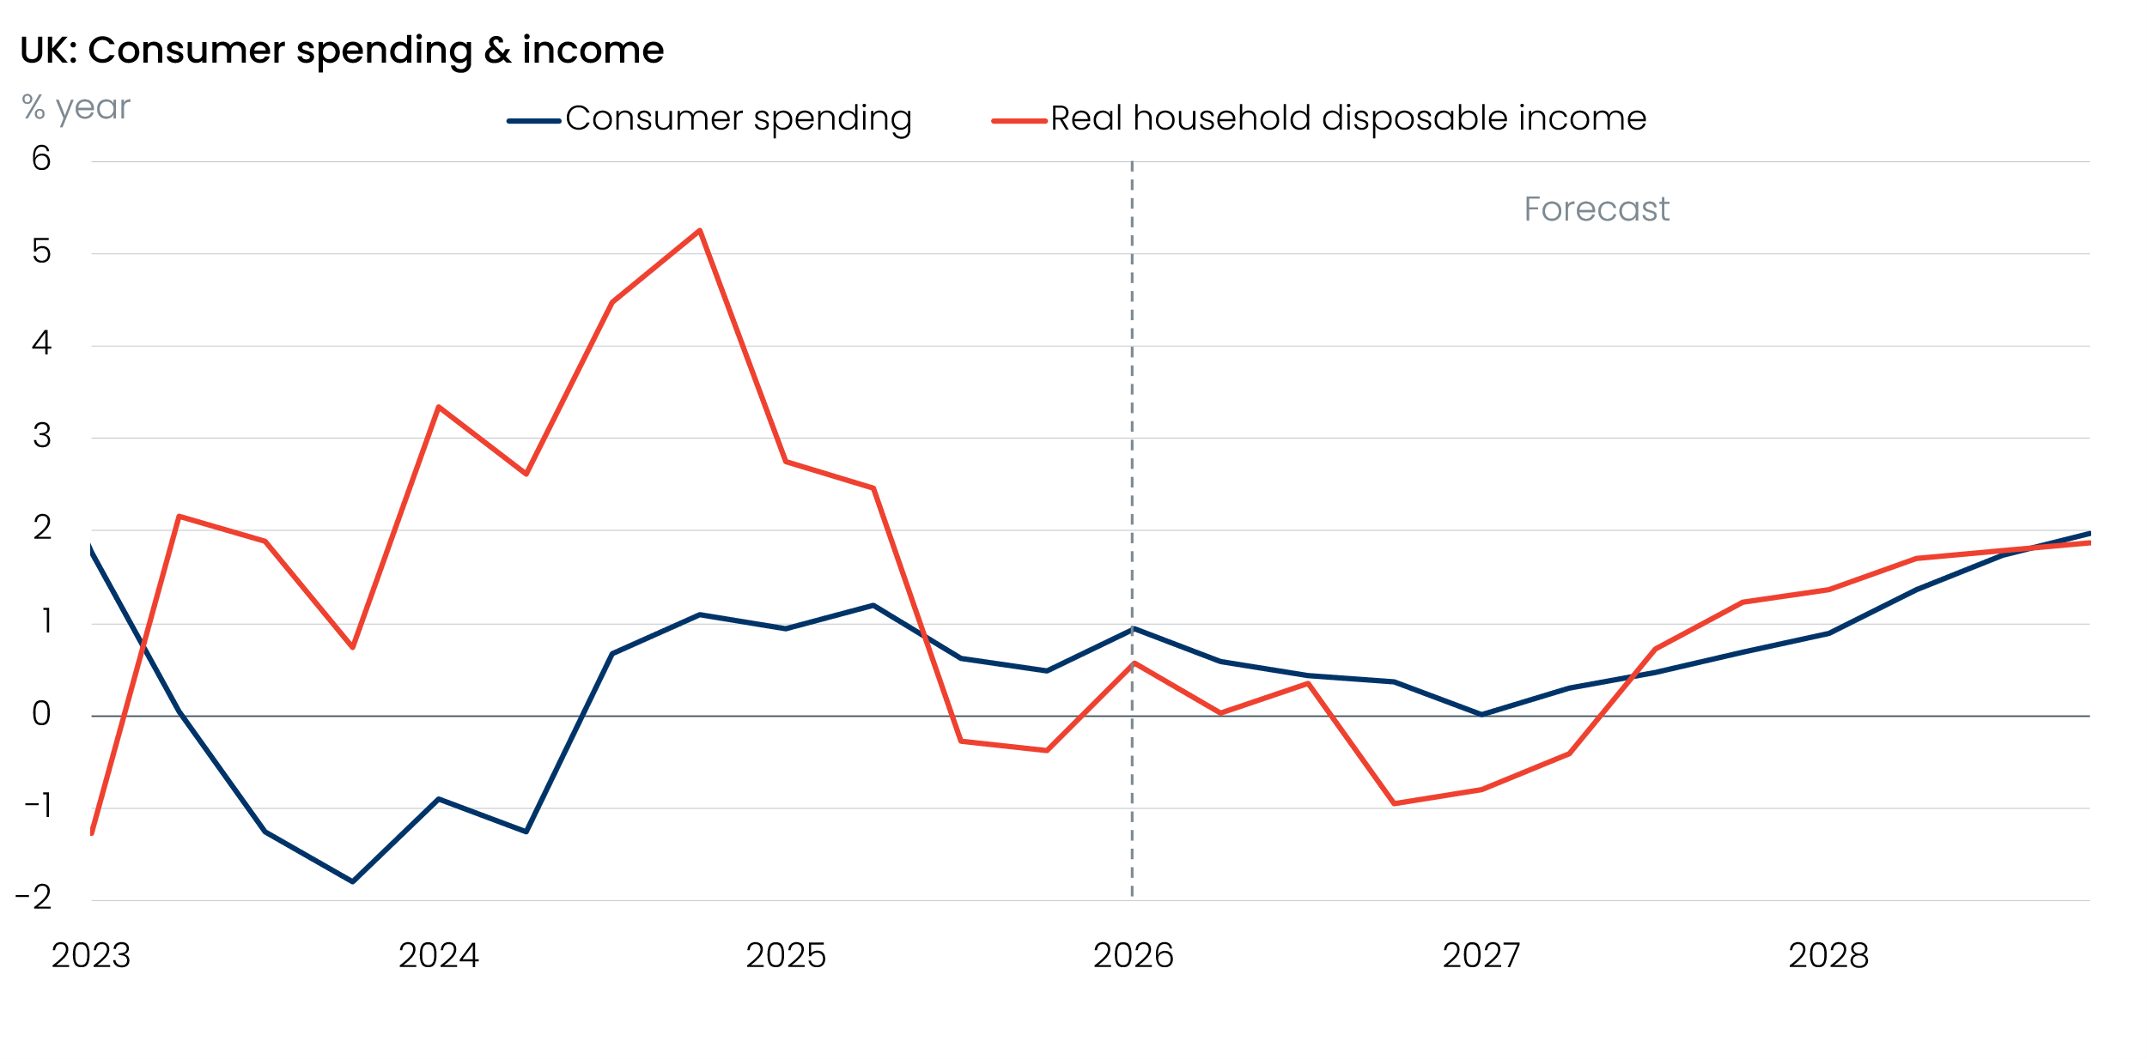
Sources: Oxford Economics, Haver Analytics

Higher inflation will weigh heavily on real incomes
The recovery in household spending from the energy crisis in 2022 began to peter out last year, as inflation ticked up and pay growth cooled. The conflict in the Middle East means these headwinds are set to intensify.
Higher oil prices have already fed through to domestic fuel prices. We think continued disruption to shipping through the Strait of Hormuz and damage to energy infrastructure in the Gulf will keep oil and gas prices elevated through the rest of May and June. That means petrol prices will remain high, while household energy bills are on track to rise by around 17% from July, when the next update of the Ofgem energy price cap comes into force.
At the same time, higher oil and gas prices will also push up input costs for firms, some of which is likely to be passed on to consumers over the course of this year. For example, food price inflation is likely to rise due to increases in the cost of fertiliser and plastics used in packaging. We expect these forces to lift CPI inflation to 4%-4.5% in H2 2026.
However, we suspect workers will struggle to secure stronger pay rises to mitigate the impact of the inflation burst. Labour market conditions are already relatively loose and unemployment is likely to rise further as intense cost pressures and weak consumer demand weigh on private sector hiring and support from public sector job creation wanes. This will limit workers’ bargaining power in wage negotiations. In addition, the ongoing freeze in most tax thresholds and allowances will mean that income tax and employee National Insurance Contributions will continue to rise strongly, limiting growth in take-home pay.
The government is yet to announce any major support packages to shield households from the rise in fuel and energy prices. But given the fragile state of the public finances, any support is likely to be much smaller and more narrowly targeted than the universal support offered during the 2022-2023 energy price shock. As a result, we forecast that real post-tax salaries per employee will fall by 1.7% this year, before contracting a further 0.8% in 2027 (Chart 2).
Chart 2: Take-home pay is on track to decline in real terms over the next couple of years
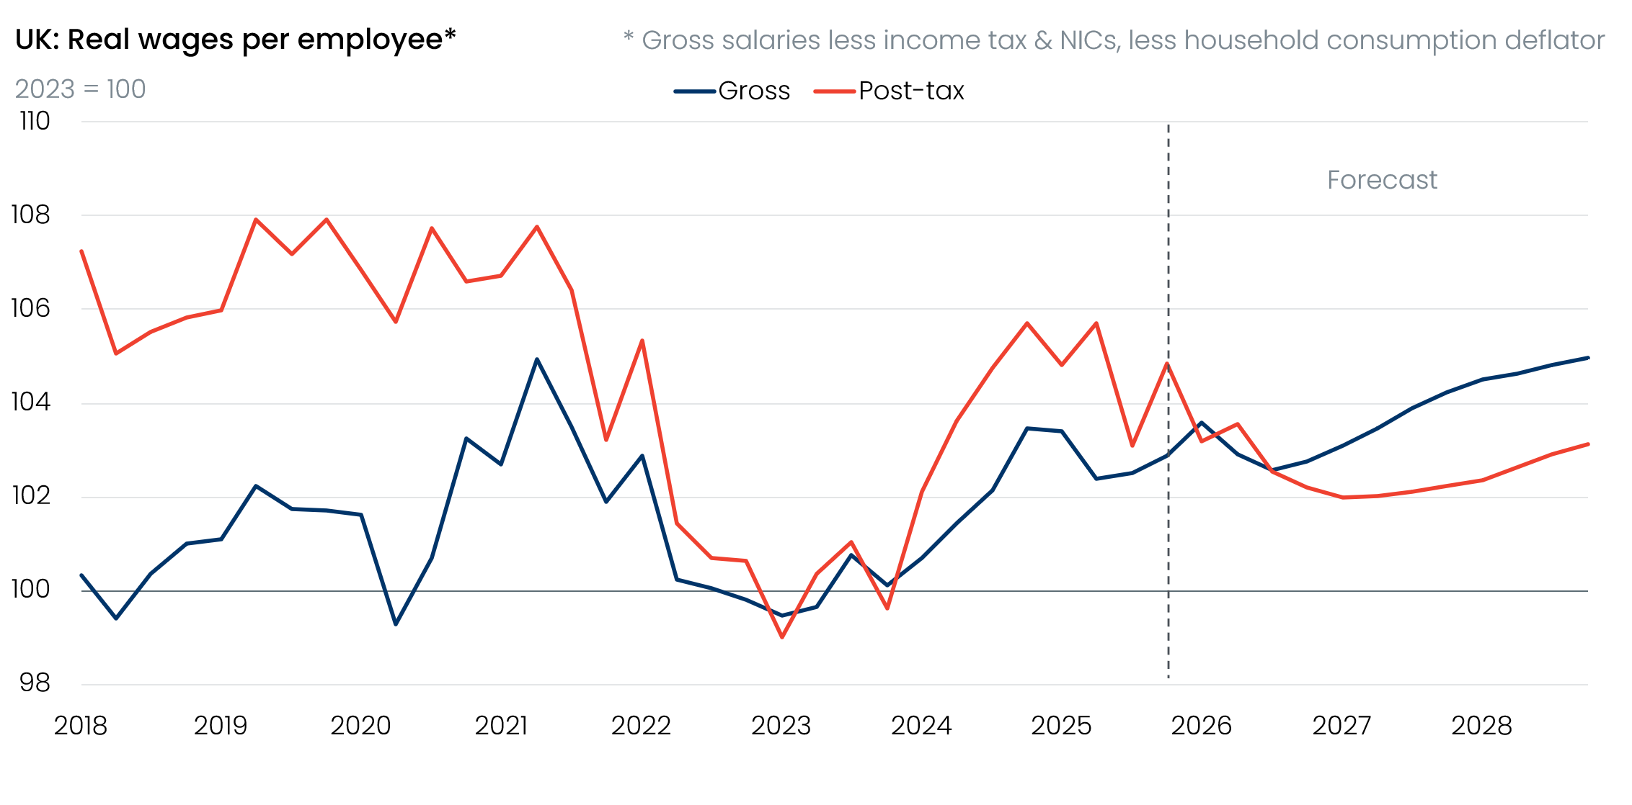
Sources: Oxford Economics, Haver Analytics

Jump in borrowing costs will compound the squeeze in spending power
The prospect of another bout of high inflation means we no longer expect the Bank of England’s Monetary Policy Committee to cut Bank Rate this year. We assume the MPC will hold policy at its current restrictive level into next year, but it wouldn’t take much to tip the balance towards some tightening.
The reappraisal of the monetary policy outlook by financial markets has pushed up quoted mortgage rates, which are now likely to stay higher than we anticipated before the Middle East conflict began. Therefore, we expect the average interest rate on the outstanding stock of mortgages to continue edging higher, pushing up debt servicing payments. Renters are also likely to suffer indirectly from the jump in mortgage rates.
The transmission of tighter monetary policy to interest rates payable on household savings should partially offset the hit to household finances from higher debt servicing costs. But even so, we still expect to move to a position where net household interest receipts impose a slightly larger drag on real household incomes over the next few years.

Households are likely to save less and borrow more to smooth consumption
Following a succession of economic shocks in recent years, heightened household financial insecurity has led to a widespread rise in precautionary savings. The BoE’s Credit Conditions Survey also suggests that the availability of secured and unsecured lending has improved significantly since the 2022-2023 energy crisis.
Most official activity and lending data still relate to the period before the start of the Middle East conflict. However, there are some tentative signs of a mood change. For example, the British Retail Consortium reported that its measures for saving expectations sank in March and April, while perceptions on consumer debt improved considerably in April.
Therefore, we think there’s a good chance that households will repeat their behaviour of 2022-2023 and mitigate some of the squeeze on spending power by saving less and leaning more on borrowing in the near-term. This should prevent a sustained contraction in consumer spending over the next couple of years, despite a reduction in purchasing power.

Experiences vary widely across the income distribution
As was the case during the 2022-2023 energy price shock, the consumer experience is likely to vary markedly across the different household groups. Data from the Office for National Statistics show that food and non-alcoholic beverages, energy, and to a lesser extent motor fuels, comprise a much larger proportion of spending for lower-income households than richer groups (Chart 3). Given the impact of the recent surge in oil, gas, and fertiliser prices will be heavily concentrated in these ‘essential’ spending categories, poorer households face a relatively larger hit to their financial position.
Chart 3: Poorer households are more vulnerable to spikes in food, energy, and petrol prices
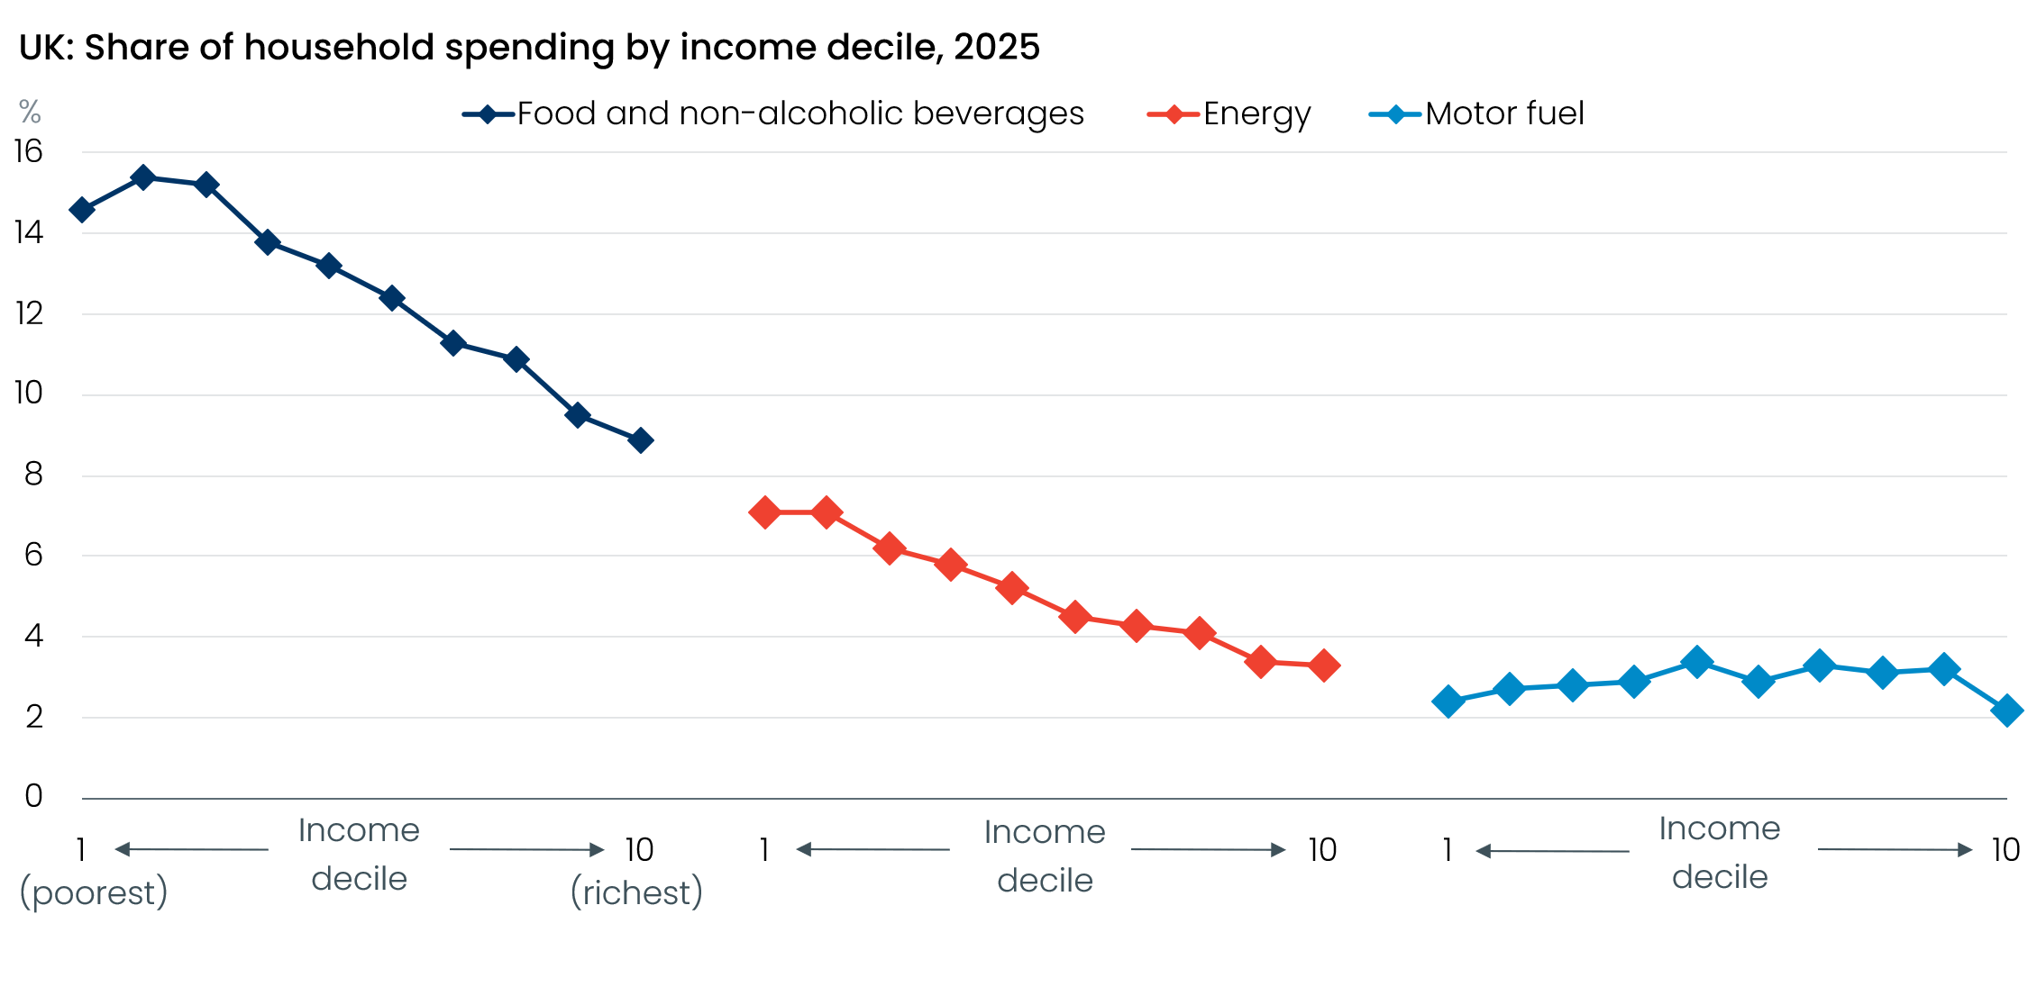
Sources: Office for National Statistics
Mortgagors refinancing cheap fixed-rate deals taken out before mid-2022 now face a more severe squeeze on their purchasing power from higher borrowing costs. In contrast, households who own their homes outright, have a mortgage that is fixed above prevailing rates, or mortgage that doesn’t need refinancing in the near term, won’t see an uplift in monthly debt servicing payments, so they should be relatively more shielded.
Those who face the largest increase in living costs this year are also less likely to have built up savings that could be used to cushion the blow. The Bank of England’s March 2026 NMG survey reported that 54% of working-age households in the bottom income quintile have savings worth less than two weeks of income. This is up from 44% in March 2022, suggesting that these households are entering the latest energy shock in a more vulnerable position than they were ahead of the last one. So while our projection that consumers will use excess savings to mitigate the real income squeeze likely holds at an aggregate level, we recognise that a significant proportion of households won’t have access to this safety net and will reduce spending to a greater degree.
The NMG survey also suggested that households in the top income quintile are now less liquidity-constrained than they were in early 2022. Given that higher-income households account for a disproportionate share of discretionary spending, and the 2022 experience showed that these households tend to cut back on spending in response to higher energy prices to a much lesser degree than other households, we suspect higher-income households will play a greater role in driving aggregate spending patterns than in past inflation episodes (Chart 4).
Chart 4: Most high-income households maintained or increased spending during the 2022-2023 energy shock
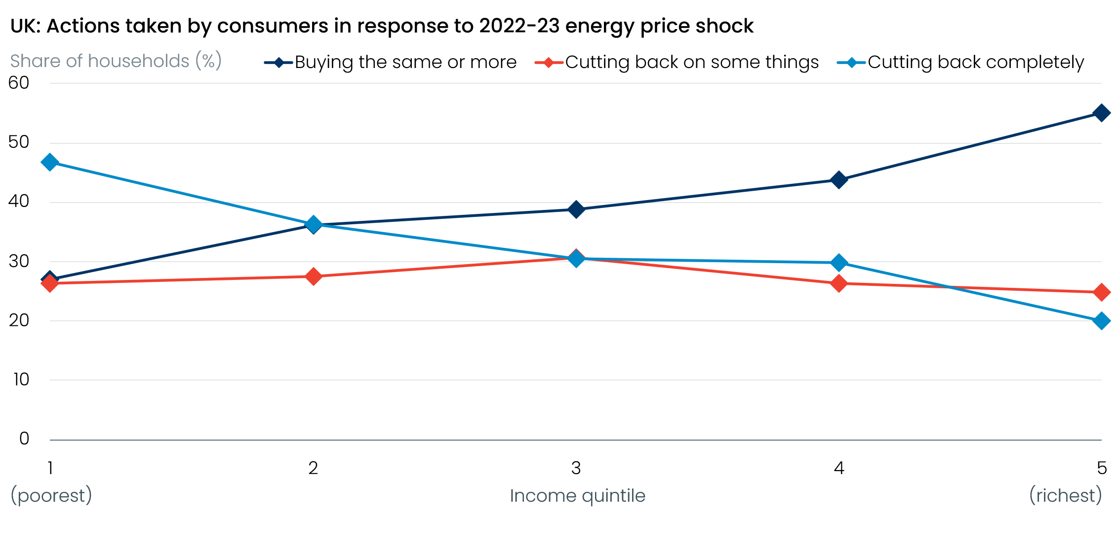
Sources: Bank of England/NMG survey of household finances
But digging below the surface of aggregate spending, the 2022 experience also showed significant changes in the mix of spending across different goods and services. Expenditure on services remained relatively resilient, despite the drop in household incomes, but there was some evidence that consumers opted to spend less on more discretionary services, such as restaurants and leisure. Durable goods expenditure – such as spending on cars, furniture, and electronics – was initially hit hardest as budgets tightened. This likely reflected these goods being bigger ticket items, which sometimes require financing schemes, and are much more discretionary in nature. In contrast, the volume of spending on semi-durable and non-durable goods – for example, on food, beverages, fuel, and housing – fell more gradually.
As a result, we expect the composition of household spending to rotate back towards necessities again over the next year, as consumers adjust to their weaker financial position.

